**Unlocking in sights into the global air transportation network with tableau**

**1. INTRODUCTION**

**1.1 Overview**

**Data Exploration: *Tableau's drag-and-drop interface makes it easy to explore large datasets from various sources. You can connect to different data sources, including databases, spreadsheets, and web services, to gather comprehensive information about the air transportation network.***

**1.2 Purpose**

**TO ANALYSIS:**

**Market Research: *Researchers and analysts can leverage Tableau to conduct market research within the aviation industry. By visualizing data on passenger preferences, travel patterns, and emerging trends, organizations can make informed decisions on route expansions and marketing strategies*.**

**Cost Optimization*: Airlines can use Tableau to analyze operating costs, fuel consumption, and resource allocation, which can be crucial for optimizing operations and maximizing profitability.***

**2. Problem Definition & Design ThinkiNG**

**2.1 Empathy Map**

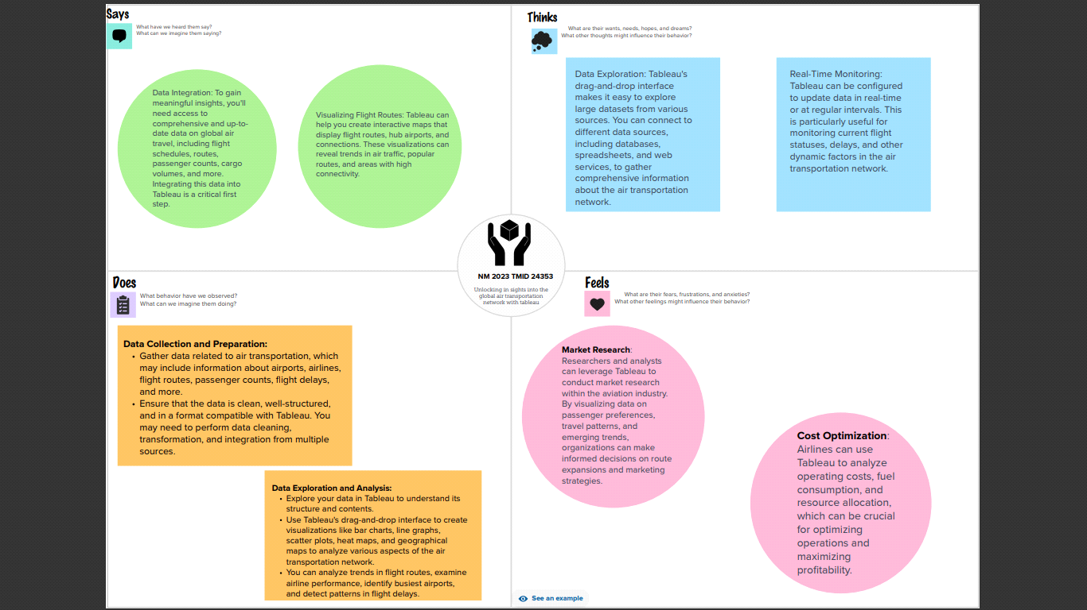

**2.2 Ideation & Brainstorming Map**

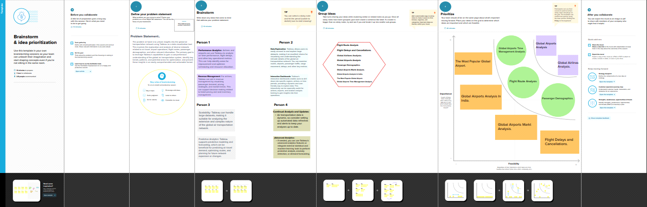

**3. RESULT**

**1)AIRLINE DATA**

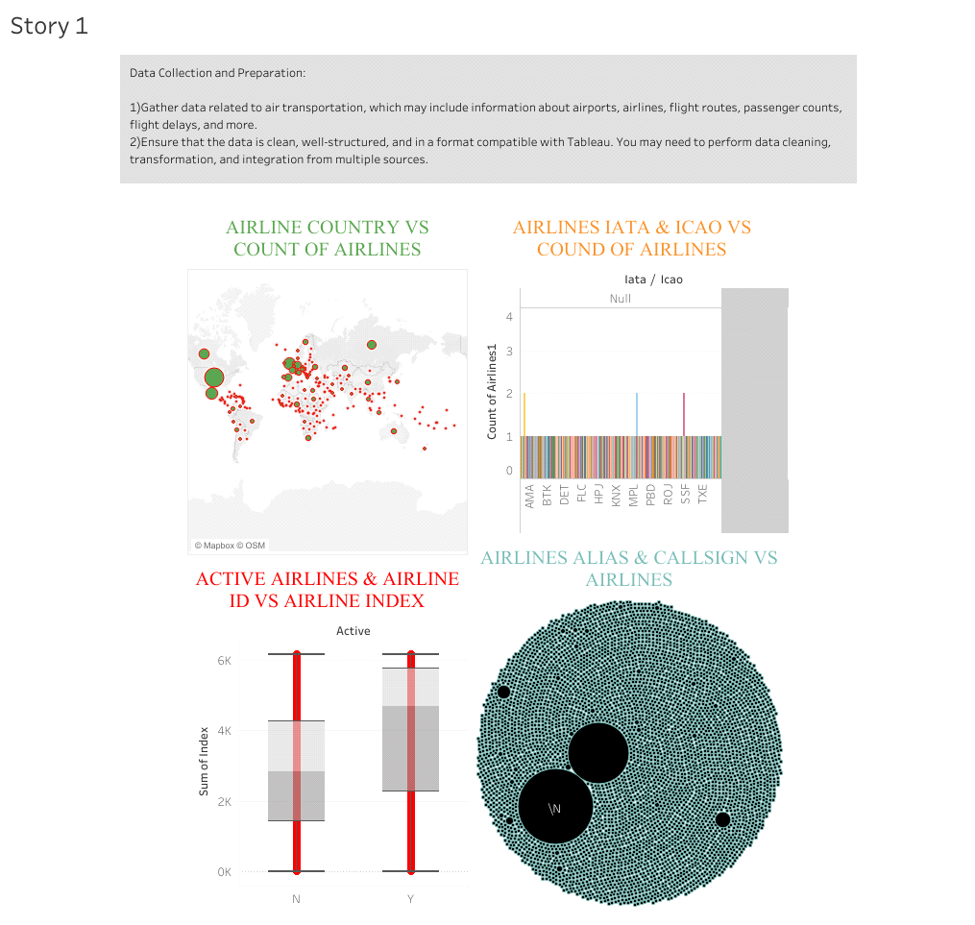

**2)AIRPLENE DATA**

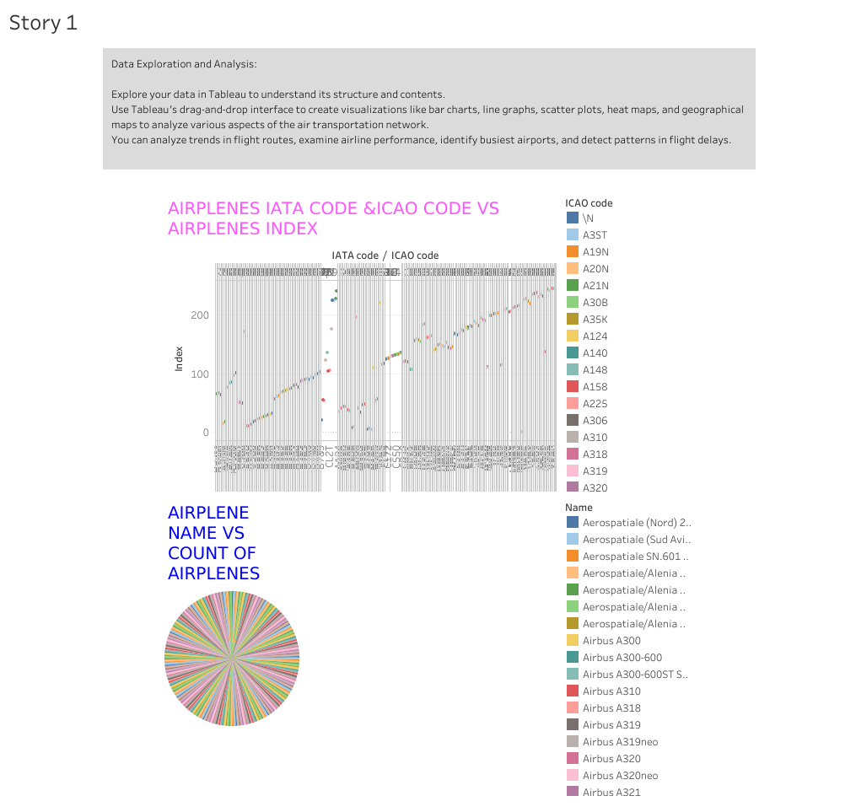

**3)AIRPORT DATA**

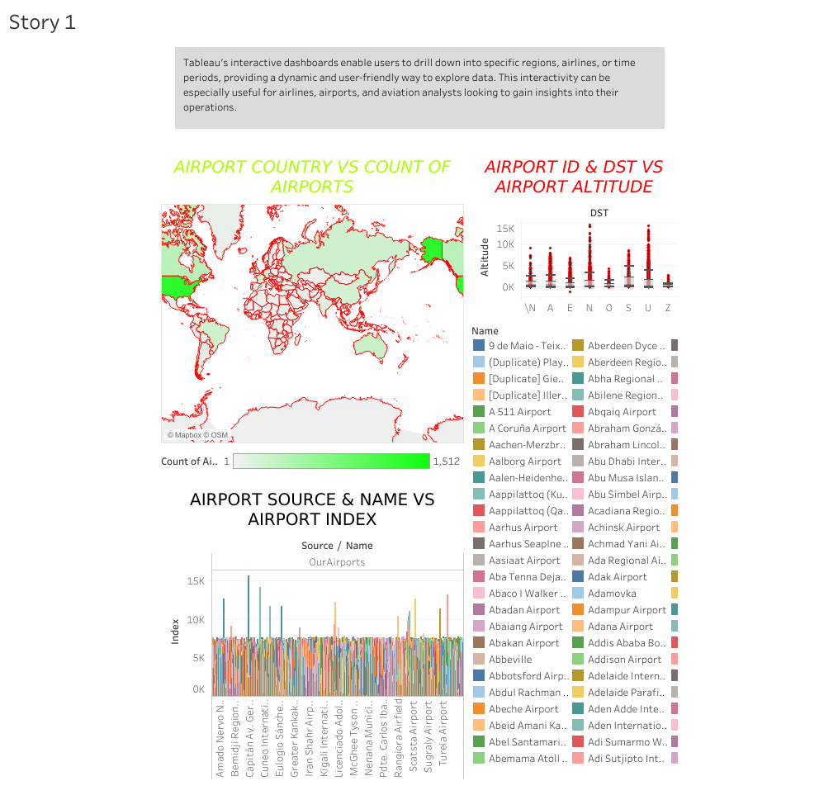

**4)ROUTS DATA**

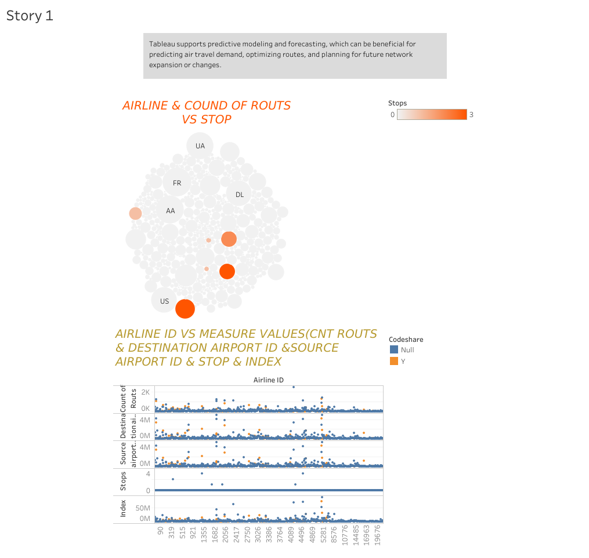

**Network Visualization:**

***Tableau allows for creating intricate network visualizations that display flight routes, hubs, and connections across the globe. These visualizations can help identify heavily traveled routes, busy airports, and patterns of connectivity*.**

**Optimized Route Planning:**

***By analyzing historical flight data and passenger demand, airlines and aviation authorities can optimize flight routes for efficiency and profitability. Tableau's analysis tools can aid in identifying the most efficient routes and adjusting schedules accordingly.***

**4 .ADVANTAGES & DISADVANTAGES**

**Advantages:**

**1) Data Visualization: *Tableau provides powerful and intuitive data visualization tools, enabling users to create compelling visual representations of complex air transportation data. This makes it easier to comprehend patterns, trends, and relationships within the network.***

**2) Interactive Dashboards: *Tableau allows for the creation of interactive and dynamic dashboards. Stakeholders can explore and interact with data in real-time, gaining a deeper understanding of the air transportation network and its dynamics.***

**3) Ease of Use: *Tableau's user-friendly interface and drag-and-drop functionality make it accessible to both technical and non-technical users. Data can be transformed into visualizations without extensive programming or data science skills.***

**4) Integration with Multiple Data Sources*: Tableau can connect to various data sources, including databases, spreadsheets, cloud-based platforms, and more. This flexibility ensures that data from diverse sources can be consolidated and analyzed in a unified platform.***

**5) Quick Insights and Analysis: *Tableau's rapid analytical capabilities allow for quick exploration of large and complex datasets. Users can perform on-the-fly analysis, enabling timely decision-making and action.***

**6) Scalability*: Tableau is scalable, allowing for the analysis of both small-scale and large-scale data sets. It can handle substantial amounts of data, making it suitable for the vast amount of data generated in the global air transportation network.***

**7) Collaboration and Sharing: *Tableau facilitates easy sharing of insights and dashboards across teams and organizations. Collaborative features enable multiple stakeholders to work together, improving overall decision-making.***

**Disadvantages:**

**1) Cost*: Tableau can be expensive, particularly for the full-featured versions. Licensing and subscription costs may pose a challenge for smaller organizations or individual users.***

**2) Learning Curve*: While Tableau is user-friendly, mastering advanced features and complex visualizations may require significant time and training. This can deter quick adoption and optimal utilization.***

**3) Limited Geospatial Capabilities: *Tableau's geospatial capabilities are improving, but they may still be limited compared to specialized GIS (Geographic Information Systems) tools. In-depth geospatial analysis might require additional tools.***

**4) Performance with Large Datasets: *Performance can degrade when handling extremely large datasets or when dealing with real-time data updates. This might affect responsiveness and user experience.***

**5) Dependency on Data Quality*: Tableau's effectiveness heavily relies on the quality and cleanliness of the data being used. Inaccurate or incomplete data can lead to misleading visualizations and erroneous insights.***

**6) Security Concerns: *Sharing sensitive data through Tableau may raise security concerns, especially if the tool is connected to sensitive databases or contains proprietary information.***

**7) Customization Limitations: *While Tableau offers a range of customization options, there might be instances where users require more extensive customizations, which may not be achievable within the Tableau platform.***

**5 .APPLICATIONS**

**1. Route Optimization and Planning:**

***Analyzing historical flight data to optimize flight routes, improve fuel efficiency, and reduce operational costs.***

***Identifying high-demand routes to strategically plan new routes or additional flights.***

**2. Operational Performance Monitoring:**

***Tracking real-time flight schedules, delays, and cancellations to manage operations efficiently.***

***Analyzing performance metrics to enhance on-time performance and customer satisfaction.***

**3. Customer Experience Enhancement:**

***Analyzing customer feedback and preferences to tailor services, onboard amenities, and flight schedules to meet passenger expectations.***

***Understanding customer behavior for targeted marketing and personalized offerings.***

**4. Load and Capacity Management:**

***Monitoring passenger and cargo load factors to optimize flight capacity and allocate resources effectively.***

***Analyzing seasonal variations and travel trends to adjust capacity accordingly*.**

**5. Aircraft Maintenance and Performance:**

***Analyzing maintenance data to predict equipment failures and schedule maintenance activities efficiently.***

***Monitoring aircraft performance, fuel consumption, and maintenance costs to enhance overall operational efficiency.***

**6 .CONCLUSION**

**DASHBOARD 1**

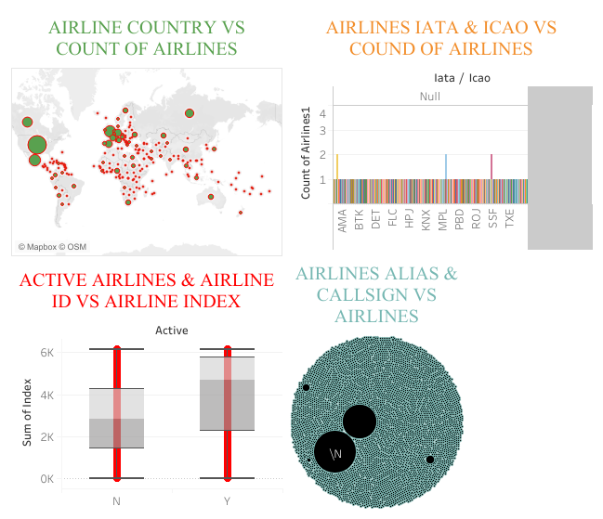

**DASHBOARD 2**

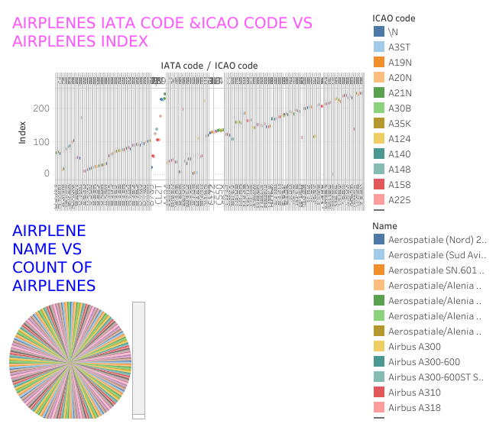

**DASHBOART 3**

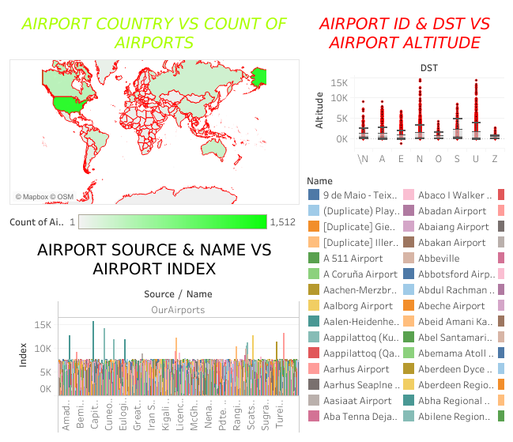

**DASHBOART 4**

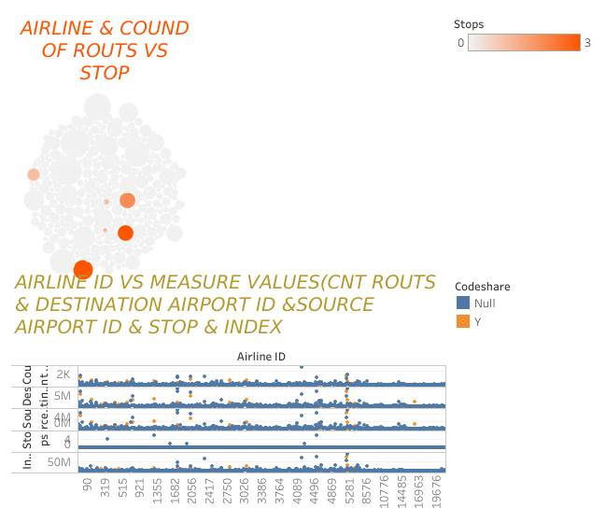

**1. Enhanced Decision-Making:**

***Tableau enables data-driven decision-making by presenting complex data in an easily digestible visual format. This empowers stakeholders to make informed choices for route planning, operational improvements, customer experience enhancements, and more.***

**2. Optimized Operations:**

***Through data analysis and visualization, Tableau helps optimize operations by identifying inefficiencies, streamlining processes, and enhancing resource allocation. This leads to improved efficiency, cost-effectiveness, and overall performance within the air transportation network.***

**3. Improved Customer Experience:**

***Understanding passenger behavior, preferences, and travel patterns using Tableau allows airlines to tailor their services and offerings, leading to an enhanced customer experience. This can result in increased customer satisfaction and loyalty.***

**7. FUTURE SCOPE**

**1. Advanced Predictive Analytics:**

***Tableau is likely to integrate more advanced predictive analytics capabilities, allowing for the prediction of air travel trends, passenger behavior, and operational challenges. Predictive models could foresee demand fluctuations, optimize routes, and foresee potential delays, enabling proactive decision-making.***

**2. Machine Learning Integration:**

***Integration with machine learning algorithms within Tableau could provide automated and deeper insights. Machine learning models can analyze complex datasets, identify patterns, and predict outcomes, further enhancing decision-making and operational efficiency.***

**3. Real-time Data Analysis:**

***Tableau will evolve to process and analyze real-time data more efficiently, enabling instant insights and responses to dynamic changes in the air transportation network. Real-time analytics will play a crucial role in optimizing flight schedules, managing disruptions, and enhancing overall operational agility*.**

**8. APPENDIX**

**PUBLIC.TABLEAUE.COM:** <https://public.tableau.com/app/profile/christober.a/vizzes>